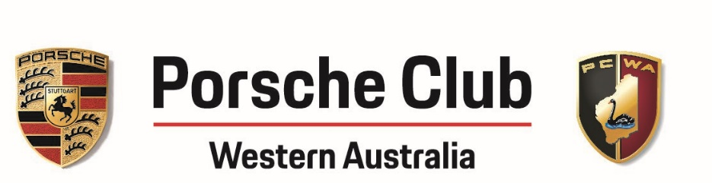

MINUTES
PCWA Club Meeting
Cottesloe Golf Club
Held on 1st September 2021 at 7.00pm

Committee Members Present:
Aaron Jones (President)
Mark Adiwibowo (Vice President)
Daniel Bathe (Sporting Director)
Chris Clarke (Treasurer)
Warren Dean (Membership Director)
Saida C. Nikolic (Secretary)

Apologies:
Hui Zhang (Social Director)
Laurie Parmenter (Webmaster)

- Welcome and membership update
New members: Darren and Tricia Farquhar
We have about 520 members altogether, 17 have not renewed yet.
The new cards are ready to be distributed.

- Minutes of last meeting on 25th August 2021
Minutes were accepted with no issues raised by members.
- Social Overview
- PDK Cup event was a successful event and members enjoyed it.
51 drivers altogether. Pizza and coffee were available as well as the much-appreciated
heaters.
No suggestions for improvements.
Summer Series PDK coming up in February.
- Targa West Perth City (Shannon’s Classics) on the Swan.
September 19th 2021 at Langley Park. 17 cars from our club will be there. Other clubs
participating as well.
- Porsche to Milky Way event in October 8th - 11th
Registration page coming up.
We have had to revert accommodation to Paynes Find Roadhouse, they have limited
accommodation so we will run the event in two separate groups (mission 1 & mission 2).
There are two registration options, arranging your own accommodation (camping) or join
accommodation provided at New Norcia & Paynes Find.
- Porsche and Planes, a morning event.
October 17th with a morning drive and finishing at the Serpentine airfield. Still looking to put
the road together.
- PCWA Club Day, will be discussed under the strategic vision.

- Sporting Series
SSR6 was held just a couple of weeks ago at Wanneroo Raceway on Sunday 22nd August 2021 hosted by the HSV Club. 60 entries with 25 from the Porsche Club. The weather was fabulous.

- Renn Klasse 1
1st Dean Pike in his 911 Cup Car with 1:00.67
2nd Davinder Manku in his GT3 Touring with 1:03.2
3rd Joe Gauci in his GT3 Touring
- Renn Klasse 2
1st Gerald Ong with a PB time of 1:05.39
2nd Daniel Bathe
3rd Emran Malhi
- Renn Klasse 3
1st Peter Ogden in his 996 911 Cabriolet with 1:10.24
2nd Colin Strickland in his newly acquired 987 Boxster S
3rd Travis Bowden in his 996
- Renn Klasse 4
1st David Posel in his 986 Boxster with 1:09.58
2nd Seamus Hannigan in his 987 Cayman just by 0.15 seconds
3rd Cheryl Leeds
- Ladies’ Plate
1st Cheryl Leeds with 1:11.50
2nd Caroline Minton
- As now we are at the end of the season, no future standings will be announced until the award ceremony at the Club Day.
- Next event is SSR7 this coming Sunday 4th September at Wanneroo Raceway.
- Driver Development Training Day: 36 responses of which 5 from female members.
Preferred days were Monday and Friday. As a result, booked is Monday 1st November for this
event. There will be a morning session and an afternoon session with a pizza lunch provided in
between. Possible to register for either or both sessions.
The registration notice will be sent next week, be quick as places are limited.

- Finance Update
A total of $95000 in the bank
Total expenses $18000 including $2500 for Bathurst, $8500 for merchandise, $1000 membership pages.
$53000 in investment account.

- Merchandise
Already made 35 orders and ordering a few more for members to buy.
Finalising the orders but still possible to add extra orders through Mark.

- Other Matters
- PCWA strategic vision: a road map to direct the club to the goal end. The lack of direction takes the club to a stagnant and not active community. The vision is to be aligned with what members want. We need your assistance to guide us with this.
We are a non-profit organisation; we aim to welcome people and promote with enthusiasm the love towards Porsche. We want to make sure we create a solid base and to put into practice members’ feedback. We need this as among the members there is not a common vision in terms of expenses of the event, sponsorships, etc.
- Concours d’Elegance event on 21 November 2021.
A lot of planning has been done so far for the club day event based on an improved
experience compared to last year’s one. As a consequence, the cost went up
from a $12000 to under $40000 (with $5000 + $1000 + 2000 sponsorship included).
This would be more of a wholistic approach based on quality. The idea is to lift club’s
standard for future as well.
This year being the 70th birthday of Porsche in Australia, we wanted to make it a bigger
event. By bringing it up to another level it takes us with more money expenses.
There is a support of Porsche Centre Club. They are offering $5000. The relationship with
Porsche Perth hasn’t been the best so by taking their sponsorship we could improve that as
well by encouraging them to participate to our events.
We need to know if we prefer more variety and quality (marquees, canape food, musicians,
more social opposed to sitting at the table, insurance) or to stay at the same level.

- This topic generated a lot of fervent discussions.
Comments from some members:
- $5000 is too small for Porsche Centre (Perry Tonking)
- If we want to entertain Porsche Centre Perth, then they need to pay more (Deryck Graham)
- Very happy with the club as it is and I believe that we are trying to match Porsche Centre
Perth’s standard. But I believe that we are already at a higher level than them (Hooman
Golestani).
- Who gets the most benefit of the investment? (Marc Sherriff)
- Is there solidarity among the committee? (John Di Giovanni)
- If the club doesn’t spend the money for this event, where does it spend on? (Joe Gauci)

- The majority of the present members seemed happy to go ahead as per last year with some minor improvements e.g., toilets.
- Some joined the club through the event (being free they could have a look while they were just walking by)
- Happy with the relaxed and family atmosphere with the emphasis on car enthusiasm rather
than glamour
- No problems in contributing financially, but it should stay free.

- It was concluded to send a survey to members:
- Stay as it is
- Budget increased but free for members
- Budget increased but members pay some amount
- Paid event

- Meeting ended at 8:40pm

Date of next meeting
6 October 2021

