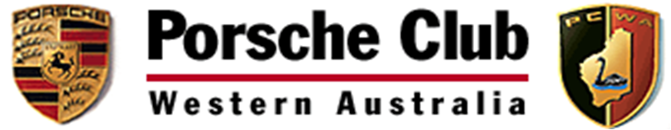

Porsche Club of Western Australia Inc
A.B.N: 85 153 133 180
PO BOX 447
South Perth
Western Australia 6151
www.porscheclubwa.org.au

Notice of Annual General Meeting (AGM) – Porsche Club of Western Australia

Notice is hereby given that the next Annual General Meeting of the Porsche Club of Western Australia Inc will be held at Chellingworth Porsche Centre Perth 101 Stirling Highway, Nedlands at 730pm on Wednesday 7th December 2016.
The election of Committee Members will take place at this meeting to determine the Club Committee for the 2017 Year.
Nominations (see website for nomination forms) for the Committee are to be forwarded to the Club Secretary at: secretary@porscheclubwa.org.au

By order of the PCWA Committee

Porsche Club of Western Australia Inc
A.B.N: 85 153 133 180
PO BOX 447
South Perth
Western Australia 6151
www.porscheclubwa.org.au

AGM OF PORSCHE CLUB OF WESTERN AUSTRALIA INC.
4 DECEMBER 2013
NOMINATION FORM FOR COMMIITTEE MEMBERS

Position:

Nominee:

Nominator:

Seconder:

Nomination Accepted (signature):

Nominations are to be sent to the Club Secretary, Drew Forster either by:
Email to Drew.forster@westnet.com.au
Mail to: PO BOX 447, South Perth, WA 6151

