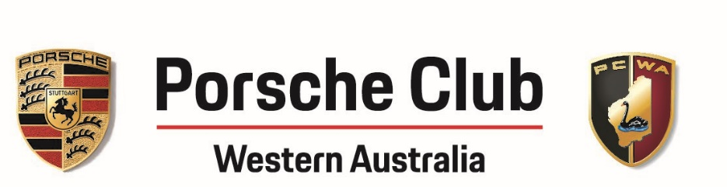

MINUTES
PCWA Club Meeting
Cottesloe Golf Club
Held on 4 August 2021 at 7.15pm
Committee Members Present:
Mark Adiwibowo (Vice President)
Daniel Bathe (Sporting Director)
Hui Zhang (Social Director)
Chris Clarke (Treasurer)
Warren Dean (Membership Director)

Apologies:
Aaron Jones (President)
Saida Nikolic (Secretary)
Laurie Parmenter (Webmaster)

- Welcome and membership update
In the last 30 days, there are 8 new members who joined the club. Welcome to new members in the meeting tonight: Nigel and Sue Crisp, Steve Aitken and potential new members Mark and Sally. 2021-22 membership cards will be printed soon and available at the next club meeting.

- Minutes of last meeting on 14 July 2021
Minutes were accepted with no issues raised by members.

- Social Overview
- The Christmas in July in Pemberton was a very successful event and members all enjoyed it. A big thank you to everyone who helped with this event including Daniel and Clare for organising the social run, Andy for being Santa, contributing the key chain for the goodie bag and making mulled wine, Laura and Mark for decorating the place and giving away all the mini Christmas trees to members that night.
- The Porsche Drivers Karting Cup (PDK Cup) is on 7 August 2021 and this is a sold-out event. Members are reminded to bring their helmets and racing spirit on that night.
- On Sunday 19 September, PCWA has been invited to display our cars at Langley Park as part of the Shannons Classics on the Swan. Modern and Classic cars are welcomed and the information is on Wildapricot. Members who display their cars will need to leave the cars there from 8am to 3.30pm and the Targa City Sprint will run along the Riverside Drive up until 12.30pm.
- In October, there will be events almost every weekend. Please see the details in the Club Calendar and updates will be provided in the next club meeting.
- Work has commenced on organising the Club Day/Concours d’Elegance event on 21 November 2021. The Club successfully managed to secure a $5000 sponsorship from Porsche Centre Perth so this year’s event is likely to be smick. Many members have already volunteered to assist with the program and if more members are interested please speak to Mark Adiwibowo. New members are encouraged to volunteer as it is a great way to know people and contribute to the club.

- Sporting Series
- In the members’ survey sent out at the beginning of the year, there were interest in participating in a PCWA run drivers training course. There has been a lot of investigation done in this and an expression of interest is now up on Wildapricot on members who are keen to participate. There will be two sessions (up to 18 drivers per session) for a day and the cost will be $350 per session. The training caters for 3 levels of experience.
- Porsche Australia is also running a Level 2 Porsche Experience on Tuesday 14 September and the cost is $650. Participants may need to complete level 1 before attending but they can find out more information from Porsche Australia.

- Porsche Club WA Finance Update
- Wildapricot has issues processing payments for amended invoices. Laurie is currently looking into this and members who have amended invoices can pay their outstanding amount via bank transfer. Members are encouraged to ensure correct details are put in to avoid the need to amend invoices.
- Chris and Laurie will look into this.

- Merchandise
- Mark has finalised the Club Merchandise which will be available on Wildapricot for purchase in August. Daniel kindly modelled some of the sample merchandise for members. A list of merchandise is also passed around during the meeting for members to have a look.
- All products will have the PCWA logo printed on them.

- Social media
- Latest video of Daniel guiding us through a wet Wanneroo Track is up on all social media platforms. For those who want to relive the Christmas in July event please go to Instagram and click on ‘Christmas in July’ highlights in the stories.

- Other Matters
- Member raised the issue of having a plan for the surplus the club has. Whether there will be consideration of including a piece of merchandise as a gift to new members. The Committee is currently working on this and this is something that has to wait till Merchandising is finalised which is very soon.
- Member discussed the idea of having a Christmas Party. This is something the Committee will look into in 2022.
- There is supposed to be a raffle for two V8 Supercars ticket tonight. Since it is cancelled, this has been replaced with five $50 vouchers for PCWA merchandise. Congratulations to the following winners:
  - Nick and Pat Mansfield
  - Paul and Vicki Dodds
  - Cleve and Zavier Riches
  - James and Jean Petkov
  - Deryck Graham and Grace Tan
- Congratulations to Myles and Ros Ferguson, Klara Forrest and Werner Bruder for winning the hamper contributed by Vera.

Date of next meeting
1 September 2021

